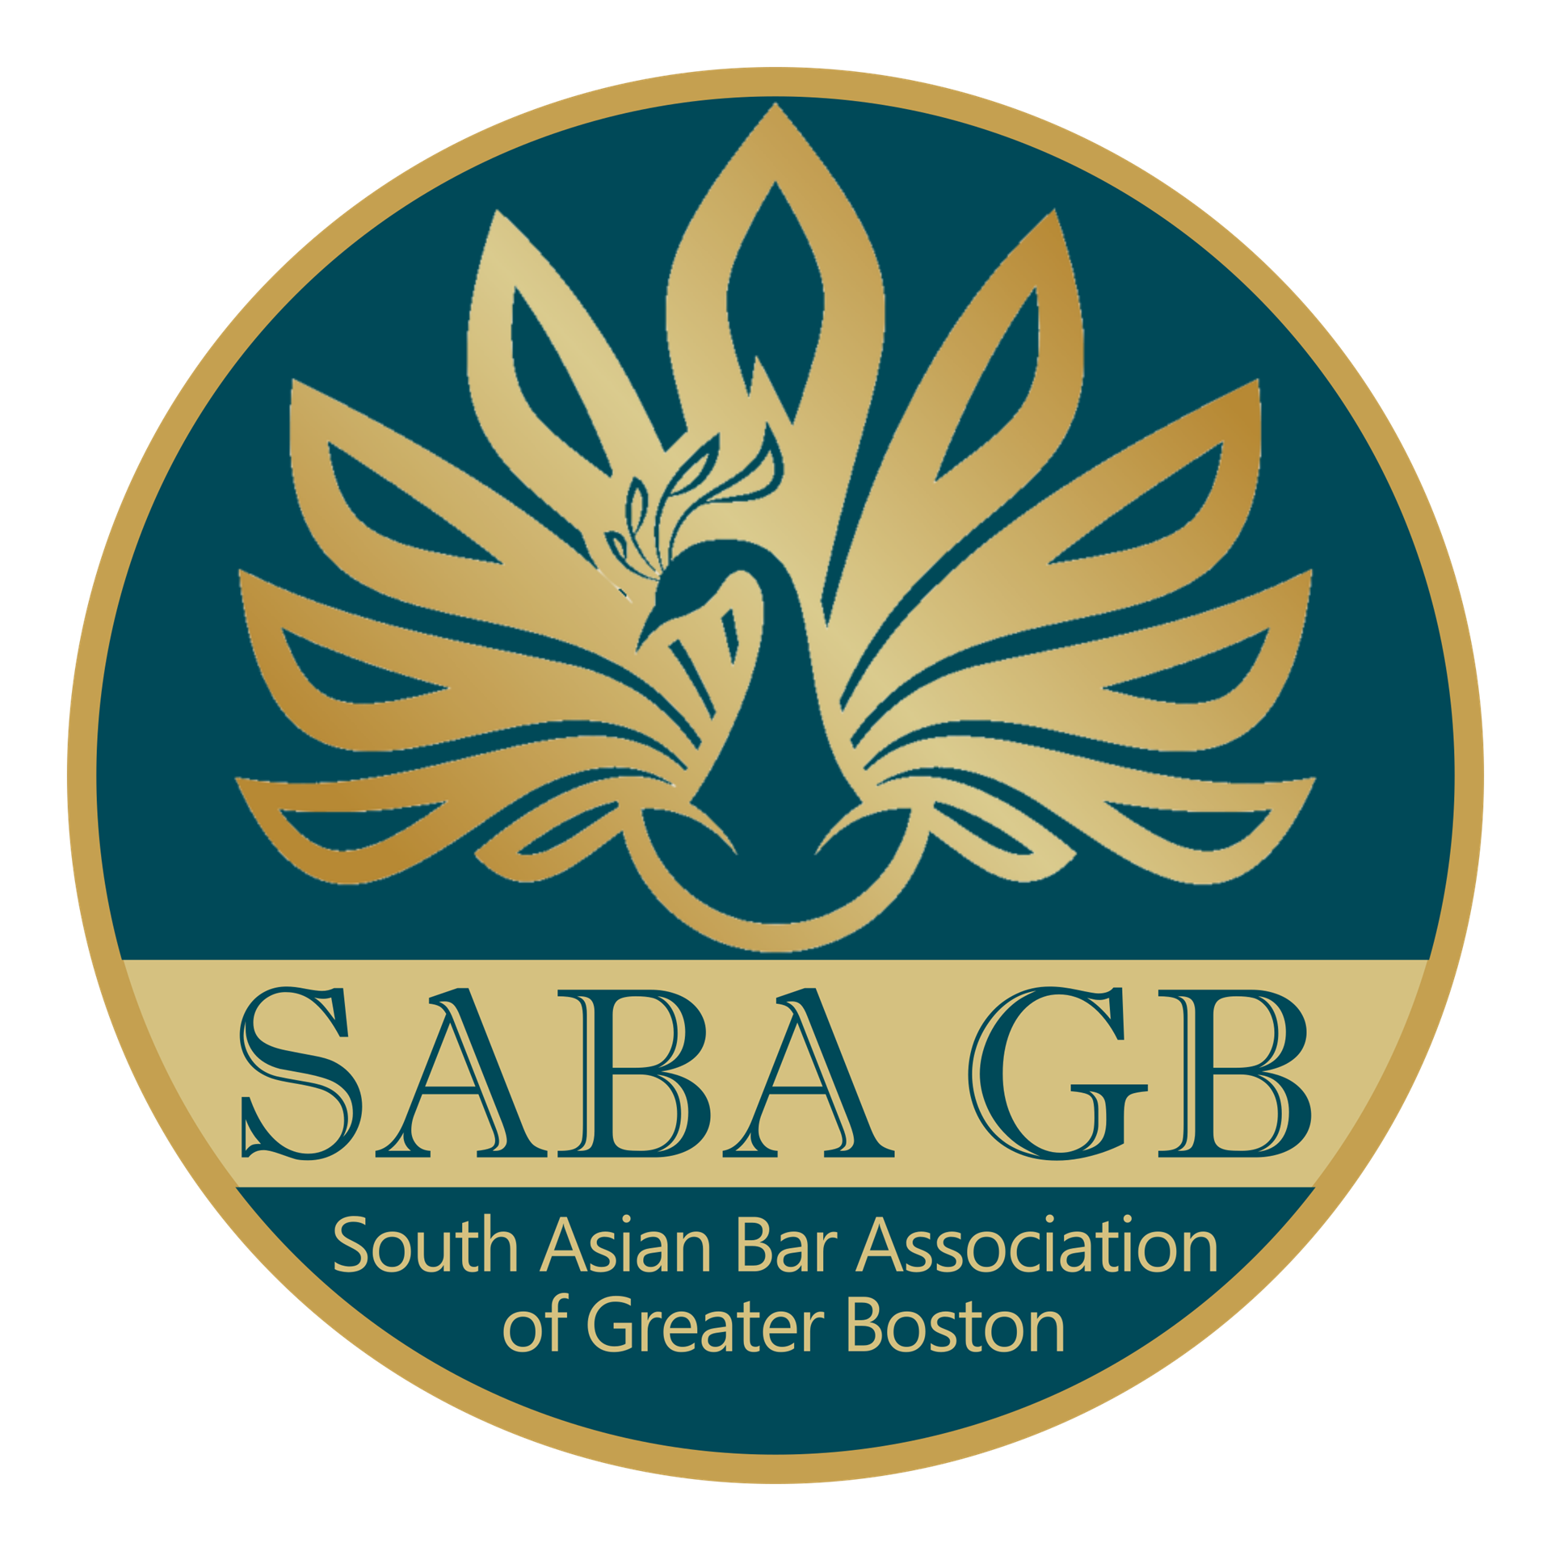
South Asian Bar Association of Greater Boston (SABA GB)
Public Interest Fellowship Application Form

SABA GB is proud to announce its 2024 Public Interest Fellowship Program. The program is intended to provide funding in an amount up to $5,000 per student for either:
- law students of South Asian descent working over the summer in otherwise unpaid legal positions at non-profit or government organizations; and/or
- law students working in an unpaid legal internship focusing on the needs of BIPOC/LGBTQ communities.

Submission Instructions
Please complete and email this Application Form, including the Certification, with the subject line, “SABA GB Fellowship Application” to the SABA GB Mentorship Committee at sabagbmentorship@gmail.com. Please include the following documents:
1. Your resume;
2. An official law school transcript; and
3. One letter of reference from a former employer or law school professor.
Documents should be attached in PDF format. Electronic signatures are acceptable.
Please save your application materials with your last name in the file name of the document.
You will receive an email confirming receipt of the application shortly thereafter.
Please note that all applications must be received no later than April 15, 2024.
Contact Tara Singh, Kritika Shukla and/or Krithika Rajkumar, SABA GB Board Members and Mentorship Committee Co-Chairs, at sabagbmentorship@gmail.com with any questions. Any questions regarding the Fellowship should be sent in prior to the deadline.
Part One: Personal Information
Name: ____________________________________________________________________
Address: __________________________________________________________________
___________________________________________________________________________
Phone: ____________________________________________________________________
Email: ____________________________________________________________________
Part Two: Education
Law School: _______________________________________________________________
Expected Date of Graduation: ________________________________________________
JD or LLM: _______________________________________________________________
GPA (if applicable): _________________________________________________________
Please list any extracurricular/community activities you are involved in at law school:
_______________________________________________________________________________________________________________________________________________________________________________________________________________________________________
Undergraduate College/University: _____________________________________________
Year of Graduation:_____________________ Degree(s):____________________________
Please list any extracurricular/community activities you were involved in at college/university:
_______________________________________________________________________________________________________________________________________________________________________________________________________________________________________
Part Three: Organization Information for Summer 2024 Placement
Organization: ________________________________________________________________
Please identify the specific Department/Division you will be working in: _____________________________________________________________________________
Address:______________________________________________________________________
Supervisor (if known): __________________________________________________________
Supervisor’s Title: _____________________________________________________________
Supervisor’s Email: ___________________________________________________________
Dates of Summer Placement: ___________________________________________________
Expected Commitment (hours/week): ___________________________________________
Organization’s Mission: __________________________________________________________________________________________________________________________________________________________________________________________________________________________________________
Applicant’s Anticipated Responsibilities: __________________________________________________________________________________________________________________________________________________________________________________________________________________________________________
Applicant’s Title: ______________________________________________________________
Part Four: Required Essays
All applicants must answer Essay A. In addition, please submit a response to either Essay B or Essay C. Each answer should be double-spaced and no more than 500 words.
- Why did you choose this summer internship and what skills and knowledge are you hoping to gain from doing it? (REQUIRED)
- What do you think are the biggest challenges facing BIPOC/LGBTQ communities today and how would you approach those challenges?
- How has your background informed your experience as a developing lawyer?
Certification
I understand and acknowledge that I must be enrolled and in good standing at a U.S. law school during the 2024-2025 academic year (but not graduating in May or June 2024) in order to be eligible for and receive the award.
I understand and acknowledge that I have carefully read all of the terms and conditions of the Public Interest Fellowship Program (the “Fellowship”), that I must comply with all of the stated terms and conditions of the Fellowship and that my failure to do so may result in the forfeiture of the entire Fellowship award.
I understand that, if selected, my Fellowship award would constitute taxable income to me and that I am solely responsible for any and all filing, reporting and payment obligations in connection with any and all applicable Federal and state income tax laws.
I understand that SABA GB reserves the right to issue public announcements regarding the winner of the Fellowship award and to publish his/her essay and/or other information about the winner. SABA GB will provide notice prior to making any such public announcements.
I certify that all of the information submitted with and all of the statements made in this application or in any document attached hereto are true and accurate to the best of my knowledge as of the date signed below. I certify that the essay attached hereto was written solely by me and is my original work.

______________________________________________________________________
(Signature) (Date)

